Beauty and Joy of Computing Unit 7 Assessment
Write a program in Snap! that draws a design using recursion. Your recursive function should include the following:
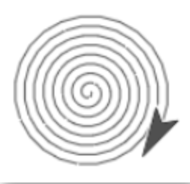
- A base case for the lowest level that stops the recursion from going on forever.
- A recursive case that calls the block itself at lower levels until it reaches the base case.

For inspiration, you may want to review the designs in Unit 7: Fractals and Recursion; however, you may not reconstruct any design you’ve already created in this unit. You may also wish to review the drawings you created in Unit 1 Lab 3: Modern Art with Polygons such as the spiral you built on Page 6, which is shown to the right.

